

A NEWSLETTER PUBLISHED BY DEPARTMENT OF ELECTRICAL ENGINEERING

DR. BAPUJI SALUNKHE INSTITUTE OF ENGINEERING & TECHNOLOGY, KOLHAPUR.



Winter 2023

- Institute Vision
To develop competent technocrats by providing quality education for the betterment of society.

- Institute Mission
M1 – To inculcate theoretical as well as practical knowledge in students.
M2 – Foster relationship between industry and institute for the benefit of all stakeholders..
M3 – Facilitating and encouraging students for continuous education and moulding them for lifelong learning.

- Department Vision
To develop competent electrical tchnocrats by providing quality education for the betterment of society.

- Department Mission
M1 – To provide a solid foundation to solve electrical engineering problems.
M2 – To create awareness about safety environment for working in electrical domain
M3 – To strengthen industry institute interaction for the benefit of all stake holdes.

- Program Educational Objectives (PEOs)
PEO-1 –Apply technical knowledge in industry and diverse fields of electrical engineering.
PEO-2 –Be ethical and professional about environmental and social responsibilities.
PEO-3 –Entrepreneur or self- employable along with life-long learning.

- Committee
  - Chief Editor (HoD) – Mr. Bhat P.P.

  - Executive Editor – Mr. Naik S.I.

  - Faculty Member – 1. Mr. Narke K.B.
2.Mr. Berlekar P.P.

d. Student Members- 1. Pranavi Sathe (TY Electrical)
2. Srushti Jadhav (SY Electrical)
“VIDYUT”- This Newsletter of Electrical Engineering Department is enlightening the various activities held during last six months in Department. This is first issue which contains overall departmental activities of students and faculty members at various platforms. I hope this newsletter will encourage our students and faculties in academic and for overall development of department and institute. My dear students and faculty always give their best development to our Electrical Engineering department also with their efforts we can achieve our goal of NBA in near future.
Mr. P. P. Bhat- HOD

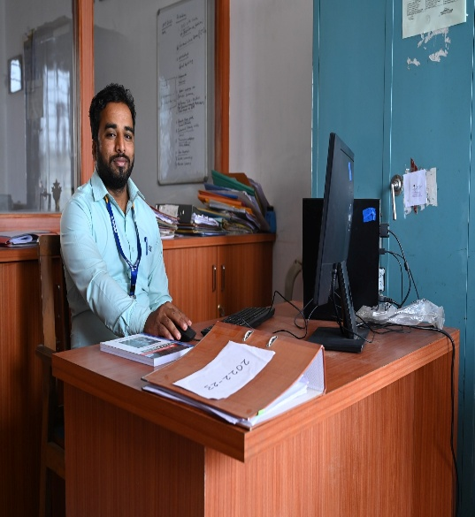
Chief Editor’s Desk: -



Academic Achievements
Winter 2023

CONGRATULATION TO ALL THE STUDENT!!!!!!!

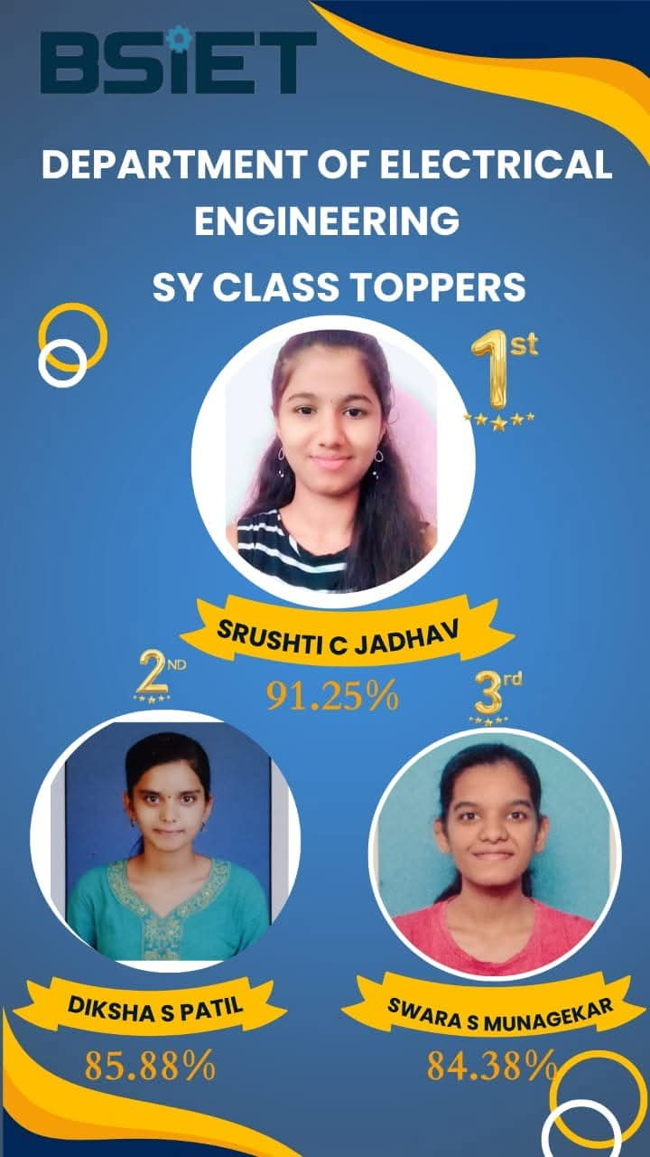
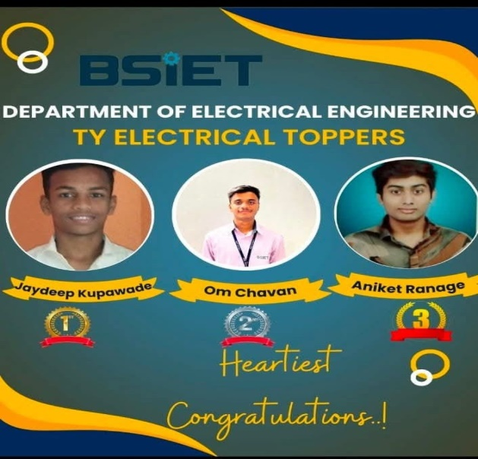

Class | Rank | Name | Percentage
FY | FIRST | PAWAR VIDHYA AVINASH | 85.88
FY | SECOND | ZORE BAJIRAV BABU | 84.24
FY | THIRD | JAKATE NIDA TABAREJKHAN | 84.12
SY | FIRST | JADHAV SRUSHTI CHANDRAKANT | 91.25
SY | SECOND | PATIL DIKSHA SUDAM | 85.88
SY | THIRD | MUNAGEKAR SWARA SANJAYKUMAR | 84.38
TY | FIRST | KUPWADE JAYDEEP DIPAK | 87.90
TY | SECOND | CHAVAN OM CHANDRAKANT | 84.40
TY | THIRD | RANAGE ANIKET SHIVAJI | 83.80

- Co-Curricular Achievements

  - More than 06 students from SY and TY Electrical has participated in national level technical event” Pioneer 24” at KIT, Kolhapur and won various prizes as well.

Industrial Visit

- Industrial Visit is arranged for Second Year electrical engineering student at R. M. Mohite Powerhouse, Radhanagri for detail study of medium head hydro power plant with the under the guidance of Mr. S. I. Naik- Visit Coordinator, Mrs. N. S. Konnur- Faculty member, Mr. P.P. Bhat- Head Department of Electrical Engg. & we are thankful to our respected principal Mr. V. D. Bhirdi sir for consistent support with us

- Industrial Visit is arranged for Third Year electrical engineering student at Suzlon Energy, Chalkewadi, Satara for awareness of Renewable Energy system also this wind power plant is a training center of the Suzlon compony & we accumulate the detail knowledge of the wind plant, with the under the guidance of Mr. S. I. Naik- Visit Coordinator, Mr. P.P. Bhat- Head Department of Electrical Engg. & we are thankful to our respected principal Mr. V. D. Bhirdi sir for consistent support with us.

- Industrial Visit is arranged for Third Year electrical engineering student at Kolhapur zilha dudh utpadak sangh,Kolhapur (GOKUL Project) for awareness of Recent automation & electrical system use in food industry with the under the guidance of Mr. S. I. Naik- Visit Coordinator, Mrs. N. S. Konnur- Faculty member Mr. P.P. Bhat- Head Department of Electrical Engg. & we are thankful to our respected principal Mr. V. D. Bhirdi sir for consistent support with us.

Expert Lecture

- Expert lecture is arranged for Second -Year electrical engineering student on the topic of Skill development and Career opportunities in boiler industry. He had shared such a wonderful experience & knowledge with our students regarding Career opportunities in boiler industry, this lecture is arranged with the under the guidance of Mrs. R. B. Bodekar - Expert lecture Coordinator, Mr. P.P. Bhat- Head Department of Electrical Engg. & we are thankful to our respected principal Mr. V. D. Bhirdi sir for consistent support with us.
- Expert lecture is arranged for Third-Year electrical engineering student on the topic of Opportunities for Electrical engineers in IT industry. He had shared such a wonderful experience & knowledge with our students. this lecture is arranged under the guidance of Mrs. R. B. Bodekar - Expert lecture Coordinator, Mr. P.P. Bhat- Head Department of Electrical Engg. & we are thankful to our respected principal Mr. V. D. Bhirdi sir for consistent support with us

- Expert lecture is arranged for Third-Year electrical engineering student on the topic of Switchgear & Protection. He had shared such a wonderful experience & knowledge with our students. this lecture is arranged under the guidance of Mrs. R. B. Bodekar - Expert lecture Coordinator, Mr. P.P. Bhat- Head Department of Electrical Engg. & we are thankful to our respected principal Mr. V. D. Bhirdi sir for consistent support with us.

Highlights

- Life skill Development program is organized by our placement cell on the date of 23rd august to 25th august 2025. During this program Ms. Pradnya Durgai, Ms. Shamli Pawar & Mr. Santosh Nalawade sir has share such a wonderful experience also training on the topic of Personality development also have share importance of effective communication and leadership in technical field. All the program organized under guidance TNP cell, all the hod’s of our institute & we are thankful to our respected principal Mr. V. D. Bhirdi sir for consistent support with us.

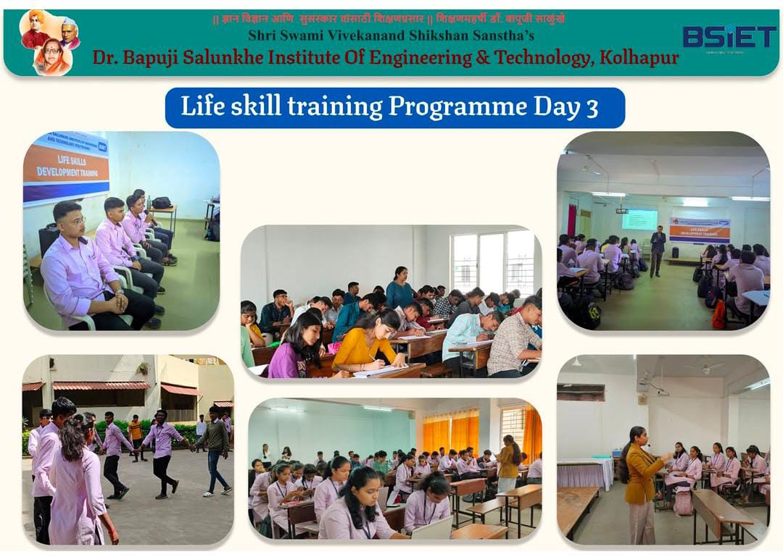

Some Glimpses in the semester

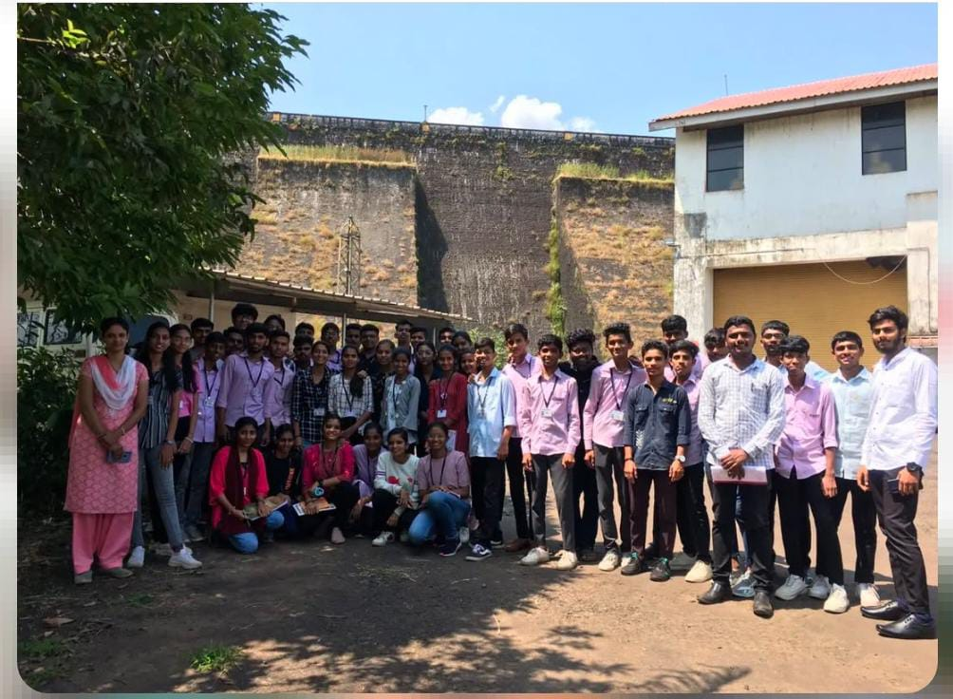

Industrial Visit to R. M. Mohite Power House, Radhanagri

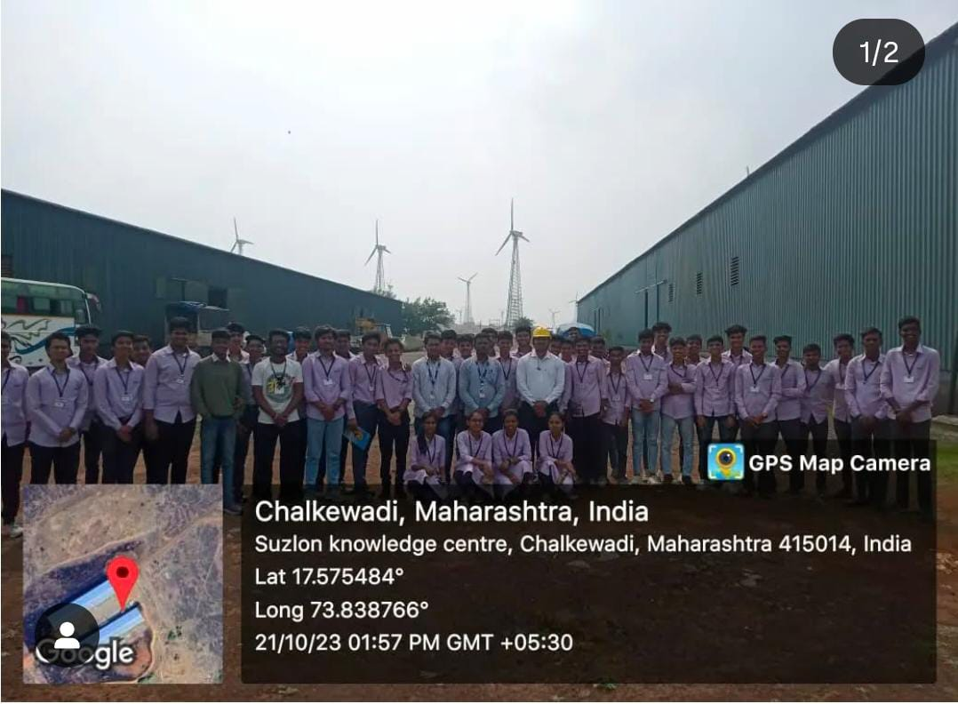

Industrial Visit to Suzlon Knowledge Center, Chalkewadi, Satara.
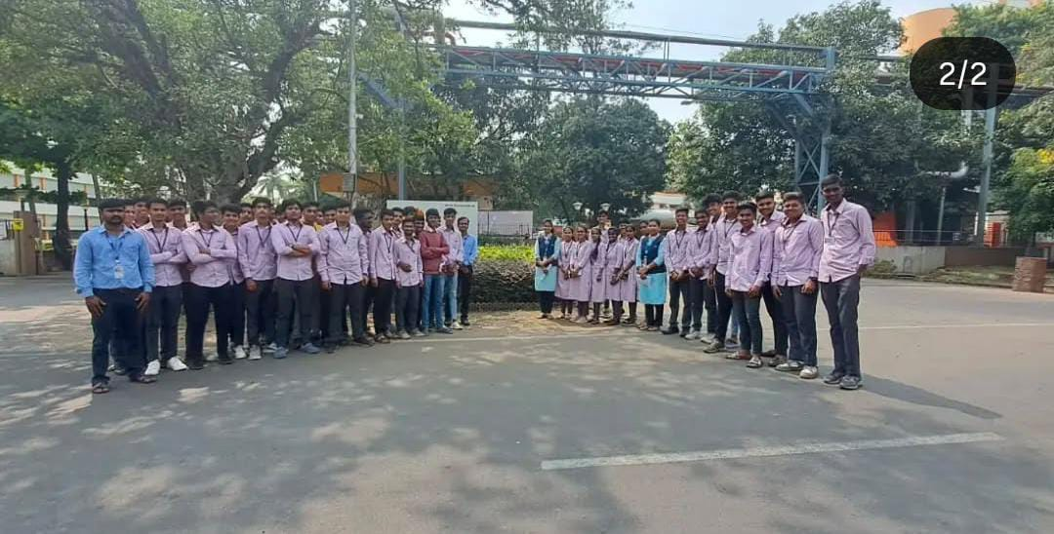

Industrial Visit to Gokul Dudh Sangh, Gokul shirgaon
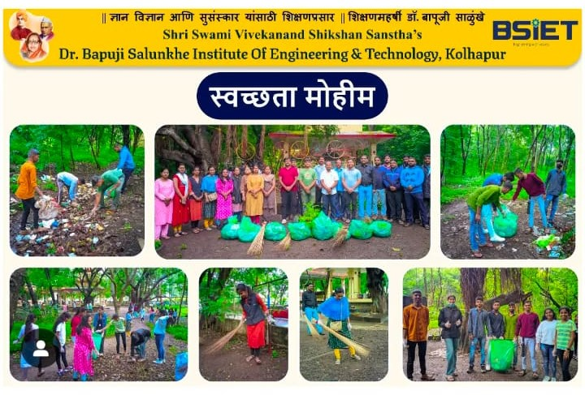
- On Gandhi Jaynti our NSS committee organized “Swachata Abhiyan” on the date 1st October 2025

